5.8 Reading Products
The clinical risks that challenge a safe pregnancy are not confined exclusively to abnormal values in medical laboratory reports. In fact, serious health risks can arise from daily exposure to common skin care and body care products. Medical professionals, dermatologists, and clinical guidance frequently recommend that pregnant women completely avoid specific cosmetic ingredients due to their potential systemic absorption and teratogenic risks to the fetus.
This caution is strongly supported by the American College of Obstetricians and Gynecologists (ACOG) [3]. In its official guidelines and frequently asked questions (FAQs) on prenatal safety, ACOG explicitly advises pregnant women to use products with verified, safe compound profiles and emphasizes the need to consult a physician for unverified ingredients. Furthermore, they strictly advise against the use of specific high-risk compounds, such as retinoids (retinol), which are clinically linked to severe developmental risks.
Driven by Nabd's core mission to proactively safeguard maternal health from all potential risks, a specialized product parsing subsystem was engineered. This subsystem is designed to scan and extract the complete ingredient list of various body and skin care products via OCR, while also providing users with the flexibility to manually input and search for specific chemical compounds. It then programmatically cross-references these ingredients against a custom, curated safety dataset compiled by the Nabd team, which maps cosmetic chemical compounds to their respective pregnancy risk levels and clinical safety classifications.
5.8.1 Risk Ingredients
To ensure the highest level of data accuracy and reliability, Nabd integrated and cross-referenced cosmetic safety information from a diverse range of reputable sources [22]-[35]. These sources include:
- Official guidelines and recommendations from specialized teratological and maternal health networks, such as MotherToBaby [22]-[23], World Health Organization (WHO) [24], Harvard T.H[25], Food and Drug Administration (FDA) [26].
- Clinical articles and publications authored by certified dermatologists and obstetricians [27]-[32]
- Evaluative studies from consumer advocacy groups and cosmetic safety activists fighting against harmful chemical exposures in personal care products [33]-[35].
By critically balancing and reconciling the data from these three distinct channels, a definitive classification matrix was established. Ingredients were categorized into two main risk tiers based on the level of consensus among the sources, with any unlisted ingredient considered safe within Nabd’s current framework:
- Avoid: This tier is reserved for chemical compounds where there is an absolute clinical consensus across all sources regarding their harmful effects during pregnancy. Under no circumstances should these ingredients be used.
- Risky: This tier includes ingredients that were flagged as hazardous by at least one source, but lack a unanimous medical consensus. These ingredients are treated with caution, as their safety profile remains a subject of ongoing debate.
- Safe: Any cosmetic ingredient that falls outside of these two specific classifications is designated as safe, relative to Nabd's current compiled database limits.
A single ingredient may include more than one name that could be mentioned in the ingredients list, or more than one derivative. Therefore, the corresponding table includes 51 names, which represent the Nabd dataset for harmful ingredients that have been collected for various elements.
Ingredient | Status | Ingredient | Status | Ingredient | Status
2-bromo-2-nitropropane-1,3-diol | avoid | quaternium-15 | avoid | sage | risky
5-bromo-5-nitro-1,3-dioxane | avoid | retin a | avoid | basil | risky
accutane | avoid | retinoids | avoid | wormwood | risky
adapalene | avoid | retinol | avoid | rue | risky
bronopol | avoid | retinyl acetate | avoid | mugwort | risky
dbp | avoid | retinyl palmitate | avoid | tarragon | risky
dehp | avoid | toluene | avoid | birch | risky
dep | avoid | tretinoin | avoid | hyssop | risky
diazolidinyl urea | avoid | retinoic acid | avoid | camphor | risky
dibutyl phthalate | avoid | avobenzone | risky | parsley | risky
dmdm hydantoin | avoid | glycolic acid | risky | pennyroyal | risky
formaldehyde | avoid | lactic acid | risky | birch | risky
hydroquinone | avoid | octinoxate | risky | oak mass | risky
hydroxymethylglycinate | avoid | oxybenzone | risky | tansy | risky
imidazolidinyl urea | avoid | paraben | risky | thuja | risky
lead | avoid | phenoxyethanol | risky | wintergreen | risky
mercury | avoid | salicylic acid | risky | -- | --
phthalates | avoid | aniseed | risky | -- | --
Table: Represent the Nabd dataset for harmful ingredients
5.8.2 Product Images Data
To rigorously evaluate and test the performance of the proposed OCR subsystem, the Nabd team curated a custom product image dataset and stored it on Google Drive [36] for seamless accessibility and model testing. The dataset was intentionally designed to simulate real-world user uploads and features various visual conditions, including:
- Full-product images capturing the entire packaging design and layout.
- Cropped images focusing exclusively on the raw text of the ingredient lists.
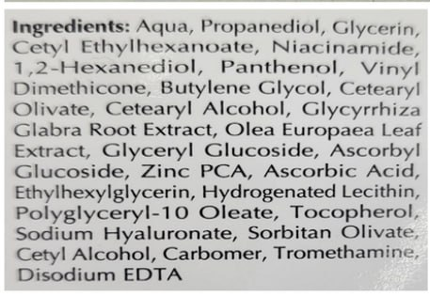
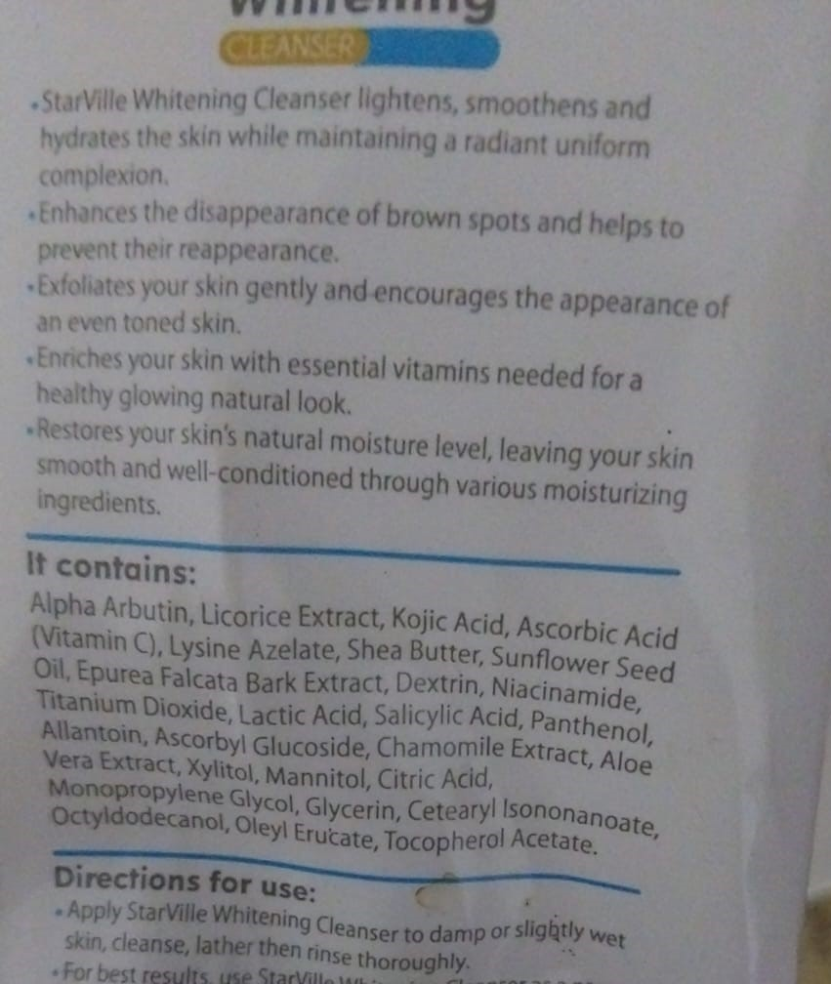
- Challenging, low-quality, or noisy images to evaluate the system's robustness and parsing accuracy under sub-optimal conditions.

Figure: Large Sample from Nabd Product Images Figure: Small Sample from Nabd Product Images

5.8.3 OCR Engine
Based on the prior experimental benchmarks detailed in Section 5.2.1, the docTR library was selected as the core OCR framework, utilizing the db_resnet50 architecture for text detection and crnn_vgg16_bn for text recognition. However, to optimize the engine's text extraction accuracy, a series of image preprocessing experiments was conducted. The pipeline concluded that two essential preprocessing steps are critical to achieving the highest parsing accuracy:
1- Grayscale Conversion:
Cosmetic and skin care packaging often features vibrant, multi-colored backgrounds and complex designs that can severely degrade OCR detection rates. Converting the input images to grayscale eliminates these color-based distractions, standardizes the text-to-background contrast, and prevents layout noise from interfering with the reading process.
2- Resizing with Inter-Cube Interpolation:
Since many testing images are tightly cropped around the ingredient lists, they often suffer from low resolution or compression artifacts. Applying a resizing step backed by inter-cube interpolation allows the system to upscale these smaller, cropped text regions smoothly. This interpolation technique preserves edge sharpness and enhances structural clarity, directly improving the recognition model's capability to read chemical ingredients.

5.8.4 Ingredient Comparison and Matching
To accurately identify harmful substances, the system must cross-reference the extracted OCR text with the ingredient risk dataset. However, because OCR outputs often contain errors or character misinterpretations, a strict string comparison would result in missed detections. To overcome this, the matching pipeline utilizes the thefuzz library, specifically leveraging its partial_ratio function.
The partial_ratio algorithm calculates the similarity score between two strings based on substring matching. It evaluates whether a high-risk ingredient from Nabd's dataset is embedded within the extracted text sequence, regardless of minor structural variations or OCR noise.

To filter out false positives while capturing true risks, a confidence threshold was established:
- If the computed match_score is greater than 85, the system flags the ingredient as a positive match.
- The matching compound is then retained and mapped to its corresponding risk classification level to alert the user.
5.8.5 Manual Text Input
Acknowledging that real-world deployment is never completely free from system or environmental errors—such as unreadable packaging or damaged product labels—the Nabd team integrated a manual entry fallback mechanism. Driven by our continuous commitment to providing the ultimate layer of protection for maternal health, this feature allows users to directly type the name of any chemical compound.
5.8.6 Technical Implementation
The product analysis subsystem is implemented utilizing Object-Oriented Programming (OOP) principles. The core business logic is encapsulated within two main functional classes, followed by a dedicated formatting layer for user presentation.
Core Classes and Modules
- product_ocr (Image Preprocessing & Extraction):
This class handles the initial ingestion and data-cleansing pipeline. It applies the designated image preprocessing configurations (grayscale conversion and inter-cube interpolation) before executing the docTR model. Once the text is extracted, the class performs casing normalization by converting the entire text output into lowercase (.lower()). This standardizes the text format and significantly improves the matching reliability.
- compare_ingredients (Fuzzy Matching Execution):
This class serves as the core evaluation engine. For manual queries, the text input completely bypasses the product_ocr preprocessing stage and is fed straight into this class. It runs the fuzz.partial_ratio to compare the normalized query (whether from OCR or manual input) against the verified risk database. When a compound triggers a match score above the 90 thresholds, the class logs the match score and maps it to its specific risk tier (Avoid or Risky).

- display (UI Formatting Module):
Once the matching logic is complete, the raw payload (consisting of flagged ingredients and scores) is passed to a separate display module. This script acts as a presentation presenter; it parses the raw technical dictionary and formats the data into a clean, intuitive visual layout tailored for the end-user on the interface.
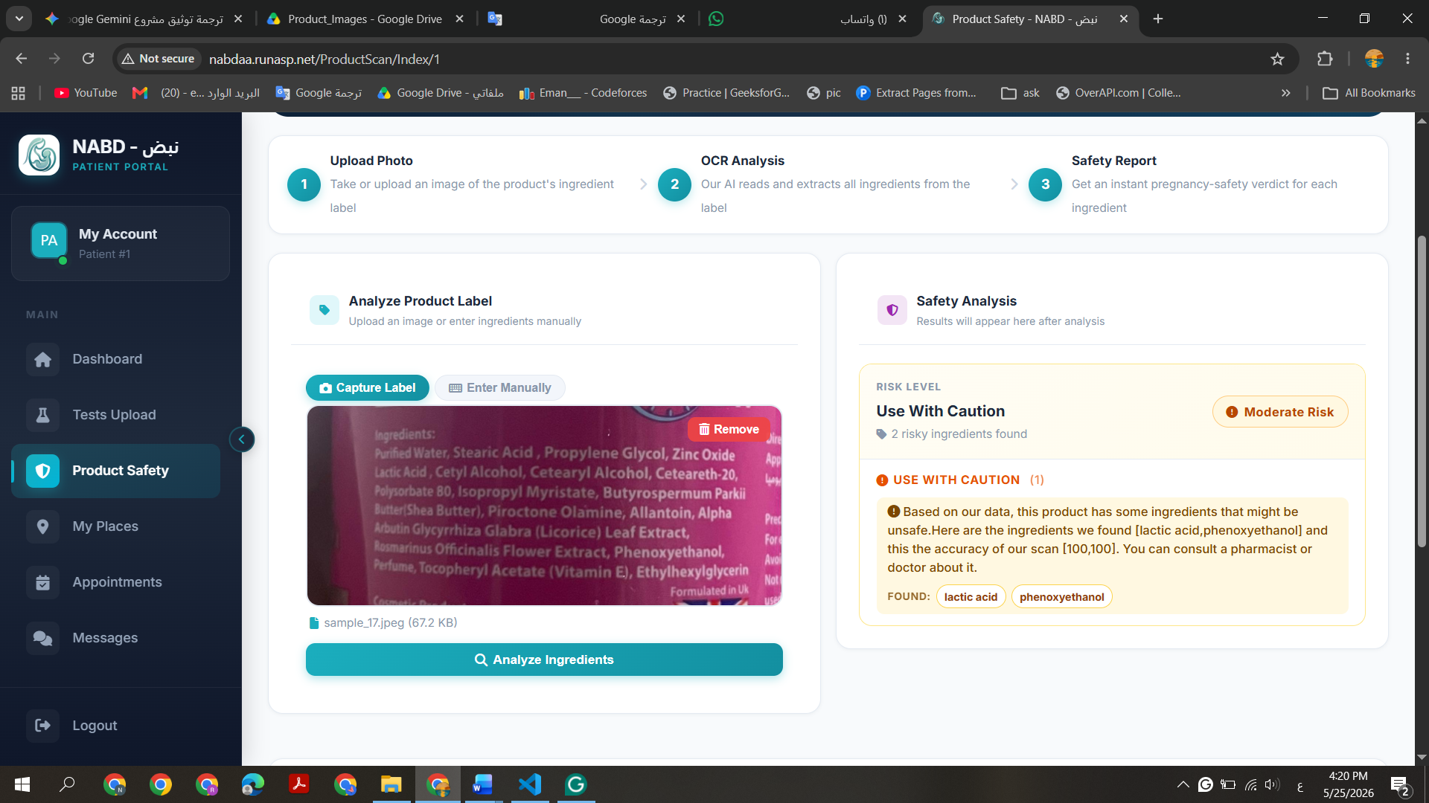

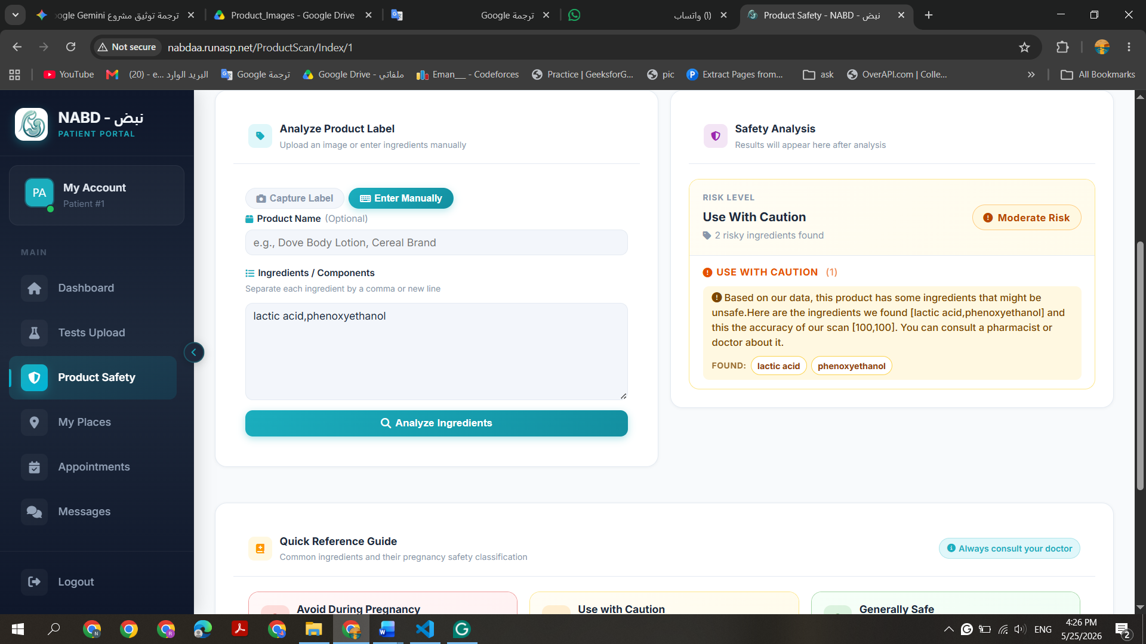

Extracted Text
Upload Image
product_ocr Class

compare_ingredients Class
Uploaded Text

Harmful
Ingredients

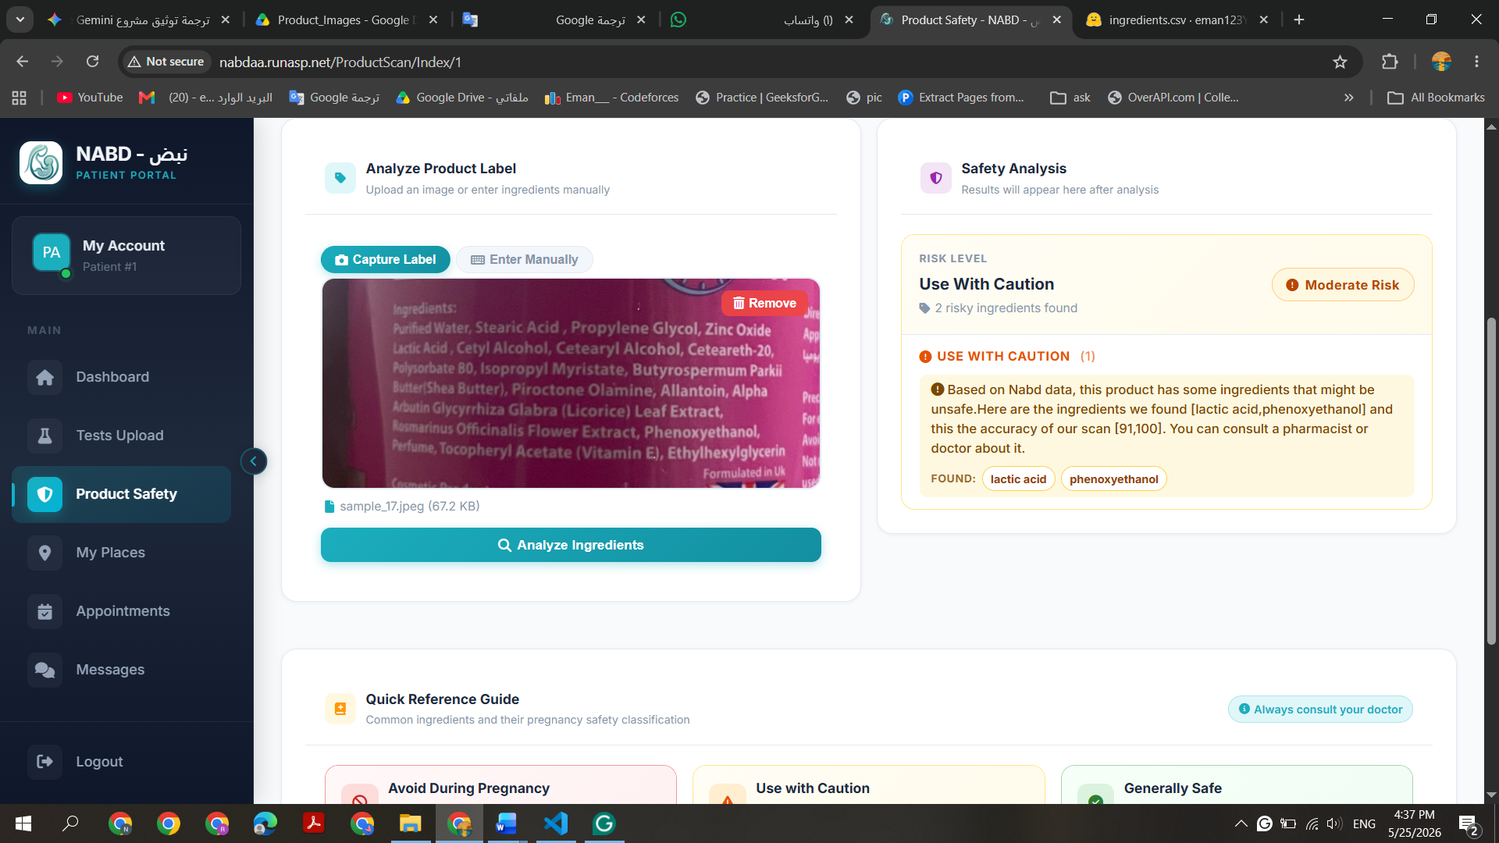
Final Result
Display Module
Figure: Nabd Reading Product Technical Implementation

